Spondee

🔹 What is Spondee
# Source: AI Source: Provided by: [Data Path: Persons Table -> ID Column: 1, Name_En Column: Motasem Essam] -> From: [Chatgpt (GPT-4-turbo)] on [8/3/2025]
A spondee is a metrical foot made up of two stressed syllables:
— —
This produces a heavy, slow, and emphatic rhythm. It often interrupts or intensifies the flow of a poem.

✅ Syllable Pattern:
# Source: AI Source: Provided by: [Data Path: Persons Table -> ID Column: 1, Name_En Column: Motasem Essam] -> From: [Chatgpt (GPT-4-turbo)] on [8/3/2025]
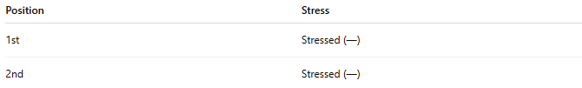
Position | Stress
1st | Stressed (—)
2nd | Stressed (—)

✅ Examples of Spondaic Words or Phrases:
# Source: AI Source: Provided by: [Data Path: Persons Table -> ID Column: 1, Name_En Column: Motasem Essam] -> From: [Chatgpt (GPT-4-turbo)] on [8/3/2025]
- HEARTBREAK
- DEAD MAN
- BIG DOG
- TRUE LOVE
- LONG NIGHT
These have equal emphasis on both syllables.

✅ Function in Poetry:
# Source: AI Source: Provided by: [Data Path: Persons Table -> ID Column: 1, Name_En Column: Motasem Essam] -> From: [Chatgpt (GPT-4-turbo)] on [8/3/2025]
- Rarely used as the dominant meter in a poem (too heavy for sustained rhythm)
- Most often appears as a substitution within other meters (e.g., iambic or dactylic)
- Used for emphasis, dramatic weight, or thematic contrast

✅ Example Line with Spondaic Substitution:
# Source: AI Source: Provided by: [Data Path: Persons Table -> ID Column: 1, Name_En Column: Motasem Essam] -> From: [Chatgpt (GPT-4-turbo)] on [8/3/2025]
From Alfred Lord Tennyson’s “Break, Break, Break”:
Break, break, break
— — —
Each word here is stressed, forming a string of spondees to convey forceful emotional impact.

✅ Contrast with Other Metrical Feet:
# Source: AI Source: Provided by: [Data Path: Persons Table -> ID Column: 1, Name_En Column: Motasem Essam] -> From: [Chatgpt (GPT-4-turbo)] on [8/3/2025]
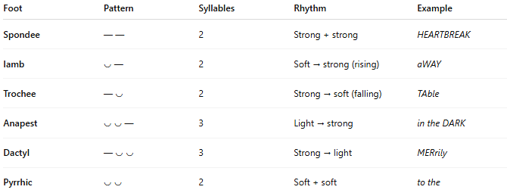
Foot | Pattern | Syllables | Rhythm | Example
Spondee | — — | 2 | Strong + strong | HEARTBREAK
Iamb | ◡ — | 2 | Soft → strong (rising) | aWAY
Trochee | — ◡ | 2 | Strong → soft (falling) | TAble
Anapest | ◡ ◡ — | 3 | Light → strong | in the DARK
Dactyl | — ◡ ◡ | 3 | Strong → light | MERrily
Pyrrhic | ◡ ◡ | 2 | Soft + soft | to the

📝 Summary:
# Source: AI Source: Provided by: [Data Path: Persons Table -> ID Column: 1, Name_En Column: Motasem Essam] -> From: [Chatgpt (GPT-4-turbo)] on [8/3/2025]
- Spondee = two stressed syllables (— —)
- Produces a heavy, forceful rhythm
- Used for emphasis or disruption in metrical lines
- Common as a metrical substitution, not a full-line pattern

